Heathfields Infants Academy Long Term Plan - As a school, we follow the KAPOW RSE & PSHE scheme of work.
For more information, visit their website: KAPOW RSE PSHE for parents
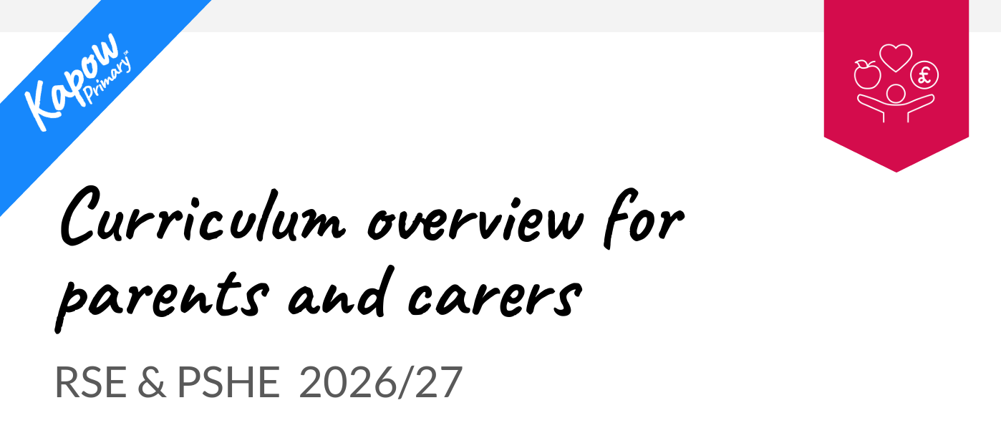

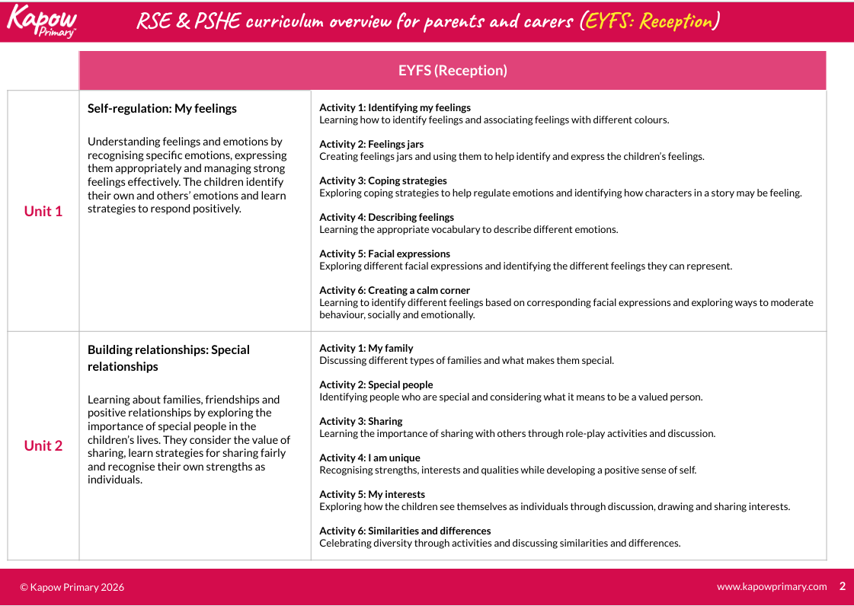
EYFS
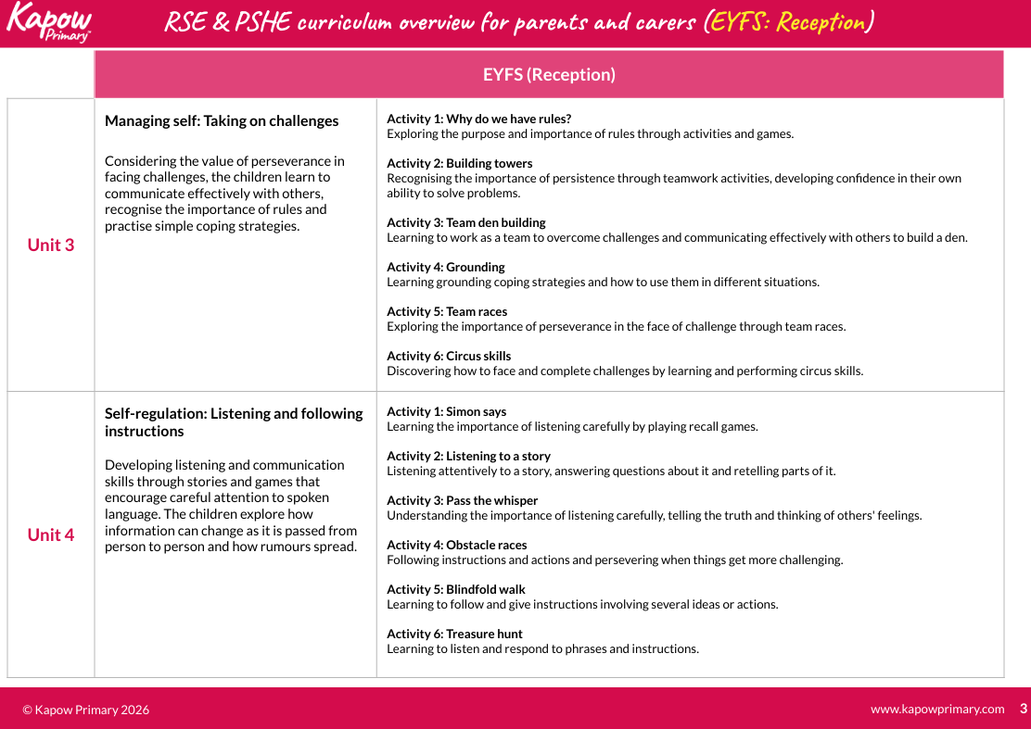
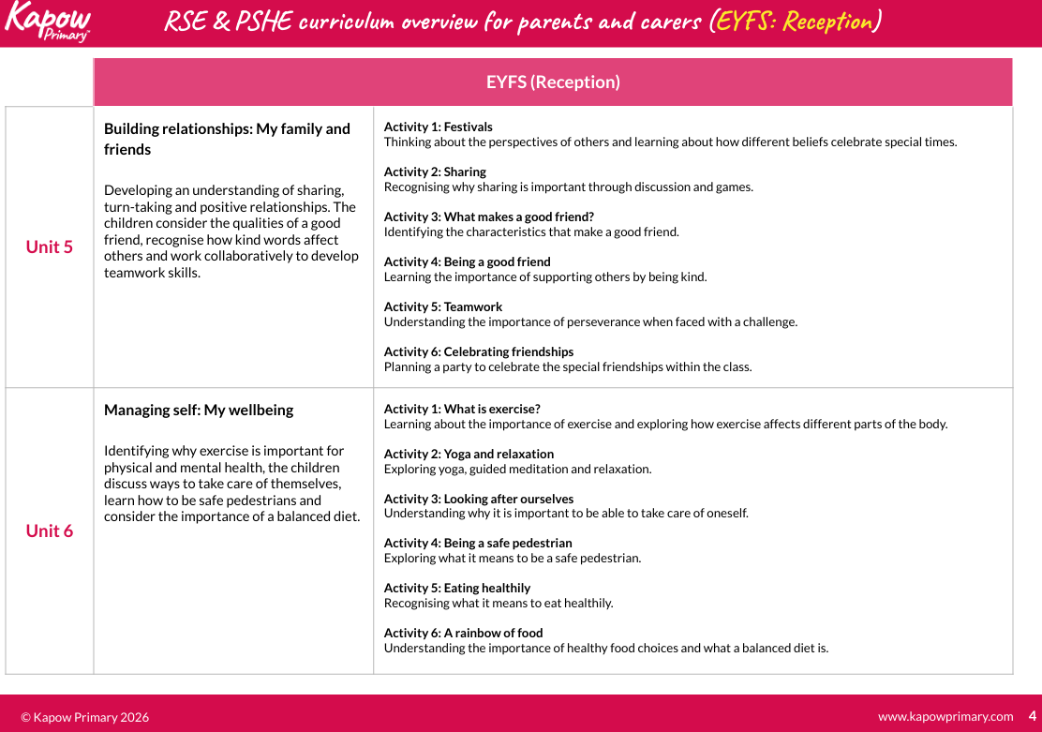

Year One
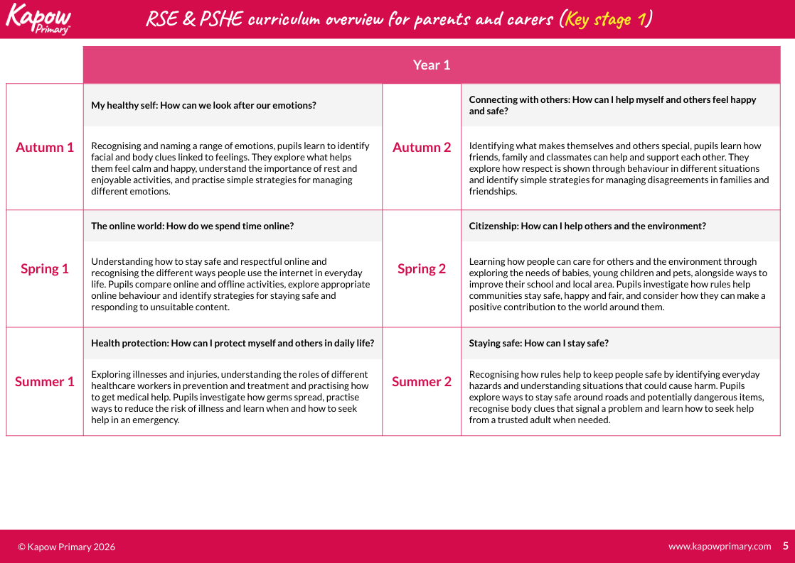

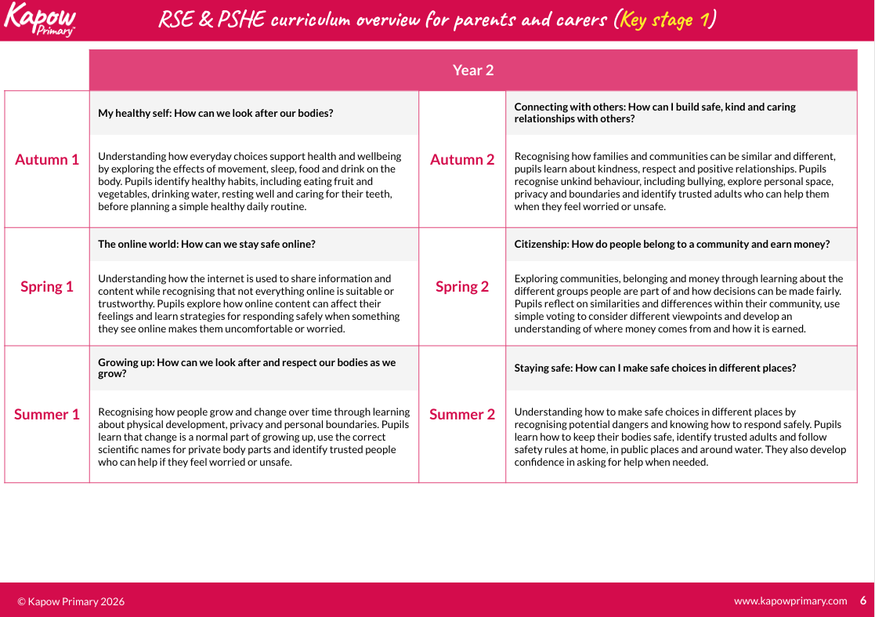
Year Two

